RF BASED HAZARD DETECTION SYSTEM

This system includes multiple Arduino-based zone devices, each equipped with sensors to detect fire, gas leakage, and overheating. Each zone is assigned a unique code, allowing the ESP32-based central hub to accurately identify the affected area and the type of hazard.

Communication between the zone devices and the hub is handled using 433MHz RF modules, which makes the system significantly more reliable than Wi-Fi-based solutions in environments like factories, where network connectivity can often be unstable. Alerts are displayed on an I2C LCD screen, ensuring quick and clear hazard identification. A buzzer is also integrated into the system to provide immediate audio alerts during hazard detection. Compared to traditional wired systems, this solution is more cost-effective, scalable, and easier to deploy, making it ideal for both existing and new infrastructures.

This prototype can also be expanded and adapted for industrial-scale applications, offering a robust and practical approach to real-time hazard detection and safety monitoring.

COMPONENTS:
CENTRAL HUB
1.ESP 32
2.RF 433MHz RECEIVER
3.16*2 LCD Display
4.Buzzer

ZONE DEVICE
1.ARDUINO NANO
2.RF 433MHz TRANSMITTER
3.MQ SENSOR
4.FLAME SENSOR
5.LM 35

SETUP:
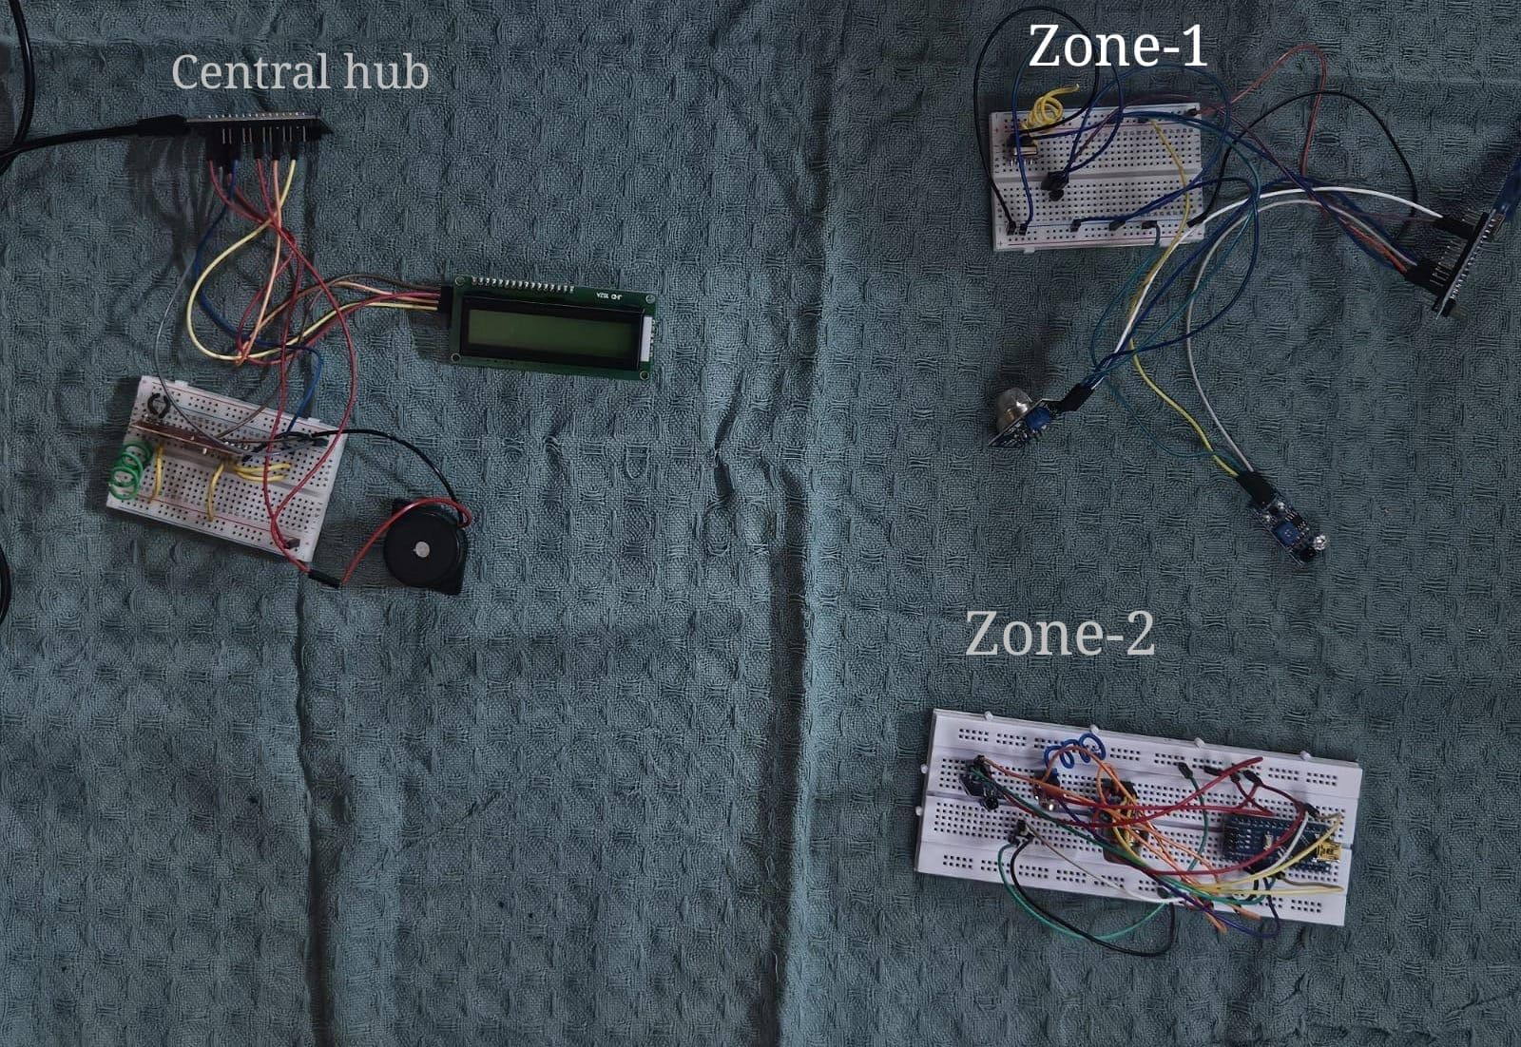

WORKING:

The RF-Based Multi-Zone Hazard Detection System works on the concept of real-time hazard detection and RF-based wireless communication. It comprises several zone Devices that continuously check environmental conditions and send alarm signals to a Central Hub upon detecting a hazard. The system provides low-power and internet-free reliable communication.

1. Constant Monitoring & Hazard Detection
Every zone device has sensors that pick up specific hazards. The Arduino Nano on the zone Device repeatedly scans data from the sensors. When any of the sensors sense an abnormal state, the system sends an alert signal.

2. Transmission of RF Signal
When a hazard is sensed, the Arduino Nano computes the information and triggers the RF 433MHz Transmitter Module to send a wireless signal to the Central Hub. The signal sent contains information regarding: The zone where the alert was initiated. The kind of hazard sensed (fire, gas leak, or overheating).

3. Central Hub Alert Processing
The Central Hub, with an RF 433MHz receiver module installed, is always monitoring for incoming signals from the zone devices. When a hazard is detected it is displayed on the lcd display linked to the central hub.

4. Real-Time Response & Safety Measures
The system gives instant alerting without a need for the internet, ensuring high reliability for use in out-of-way places and in manufacturing environments. For monitoring various spaces, Multiple zone devices can be installed to get complete coverage.

OUTPUT:

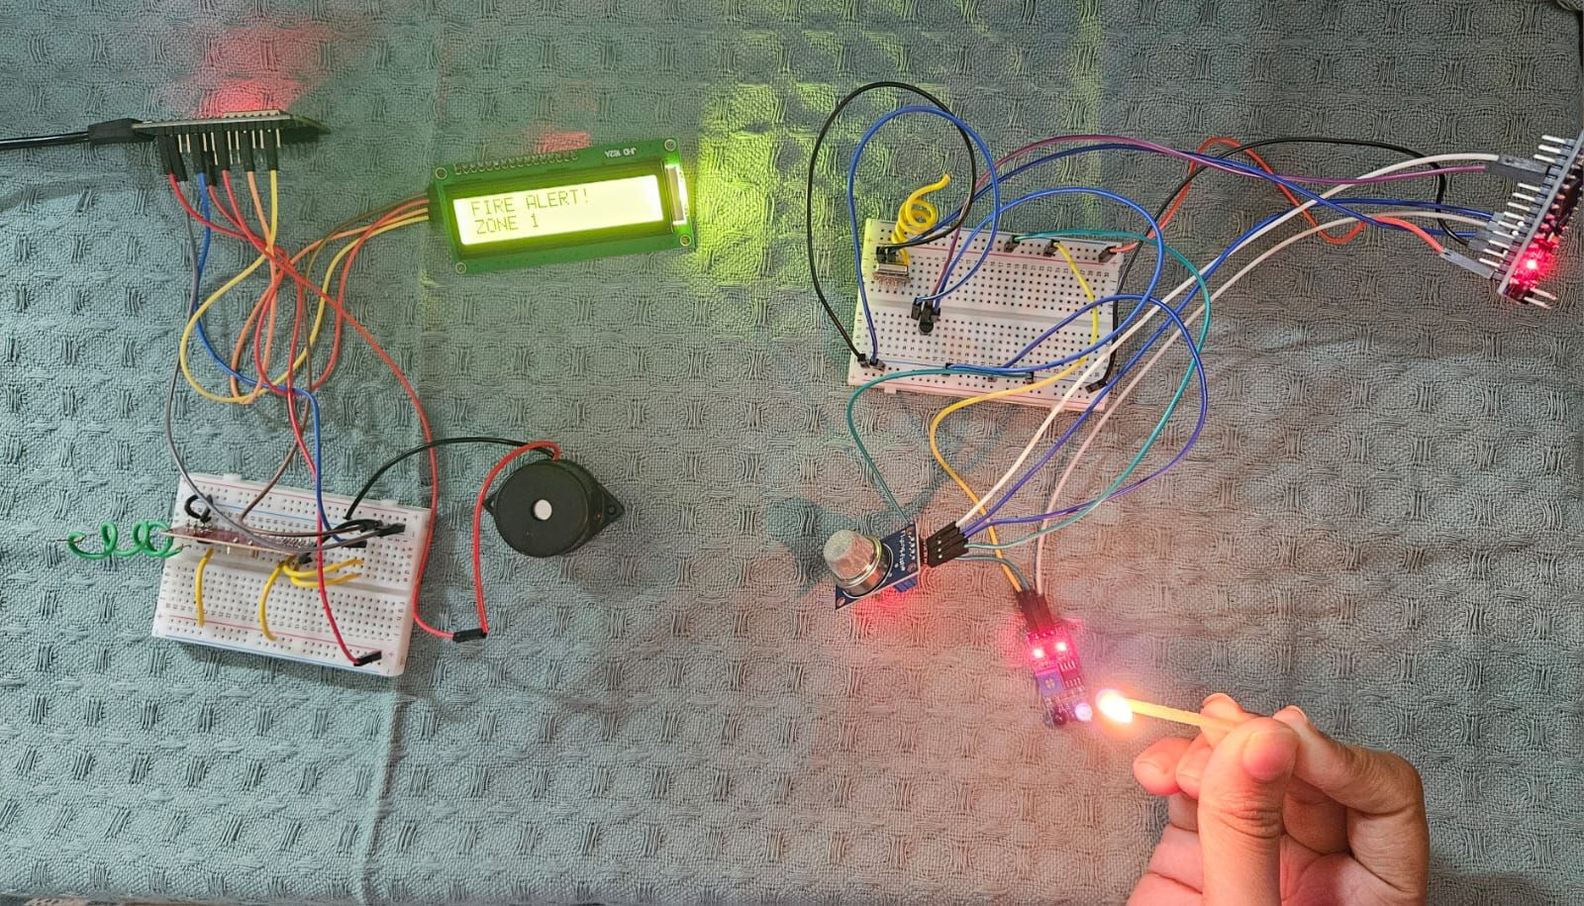
When there is a fire alert at zone-1

Whenever a hazard is detected alert is sent to the central hub via the zone device of the respective zone. The LCD display connected to the central hub displays the hazard detected and the zone in which the hazard was detected. In the above image fire was detected at zone-1 hence it was displayed on the LCD of the central hub. Buzzer linked to the central hub is also activated when the hazard is detected.

